Boston Validation Files

Step 1 (this will remain with the team)

1. Log JIRA ticket with IT requesting the data
2. Password BS(month)(year) **– BS062021**
3. Save file to location below



Step 2

* Open file
* Use tab **ADJ TRS**
* Insert a column – Column A
* Copy member number (Column K) into this new Column A
* Filter Column J per site (ie Boston Clonmel, Boston Cork, Boston Galway)
* Copy data into three separate new tabs (ie Boston Clonmel, Boston Cork, Boston Galway)

Step 3

* Insert pivot table **– For Each location???**
* Under Rows → Member No
* Under Values → Sum of Net of GD

→ Sum of TRS

→ Sum of Amount

Step 4

* Open new excel sheet and copy headings from a previous file:



* Copy member number from pivot table into Column A and I
* Copy data from pivot → Gross to Column S

→ TRS to Column T

→ Net to Columns P and R

→ Amount Paid (Column Q) should all be zero

* Do V-Lookups from Column A (Member Number) against IT data for Columns B to H
* Do V-lookup from Column I (Member Number) against IT Data for Column J

Step 5

* Download a member list from Power BI

<http://winprdan2321/reporting/browse/Reports> **- Need Access to folder**

Power BI

Member Listing

Below page appears

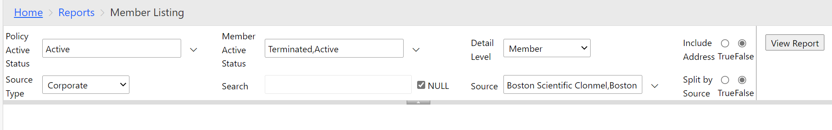

Policy Active Status – Active

Member Active Status – Terminated, Active

Detail Level – Member

Source Type – Corporate

Source – select the three Boston’s – Scroll down the list Boston Scientific Clonmel, Cork, Galway)

Include Address – False

Split by source - False

View Report

Export to Excel

* Do V-Lookups from Column I (Member Number) against member list for Columns K to O and Columns U and V
* Save file under Boston (Site) Validation File (Month) (Year)